EARN WHILE YOU LEARN
ASSIGNMENT-3

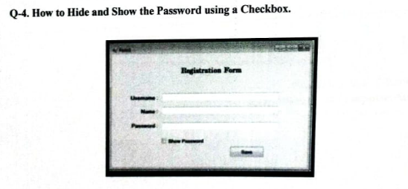

<!DOCTYPE html>
<html>
<head>
<title>EWYL ASSIGNMENT</title>
</head>
<body style="text-align: center;">
<h2>Registration Form</h2>

<form style="display: inline-block; text-align: left;">
<div>
<b>Username:</b><br>
<input type="text" name="username">
</div>

<div>
<b>Name:</b><br>
<input type="text" name="name">
</div>

<div>
<b>Password:</b><br>
<input type="password" name="password" id="password">
<input type="checkbox" onclick="document.getElementById('password').type = this.checked ? 'text' : 'password'">
<label>Show Password</label>
</div>

<div>
<br>
<input type="submit" value="Register">
</div>
</form>
</body>
</html>

OUTPUT
